Appium: mobile automation tool, can automate native, web and hybrid applications developed and maintained by Sauce Labs.

Appium is basically a Server

It supports Android, IOS and Windows desktop platforms

It supports multiple programming languages.

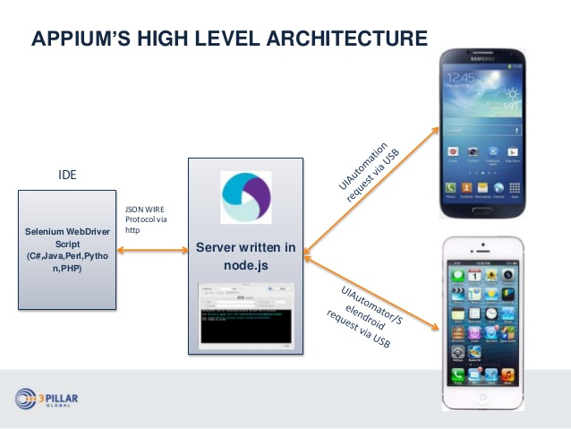

Appium Setup:

1.Jdk 3. Maven plugin

2.IDE 4. TestNG plugin 5. Selenium standalone Server.

Android Tools

1.Android Studio- used as IDE, SDK and create Virtual devices for testing apps.

2.Appium Server/ Appium Desktop

Set Environment Variable for Android sdk(C:\Users\sball\AppData\Local\Android\Sdk)

**Android SDK and platform-tools, tools, build-tools**

3.Appium Client java ( .jar file or add dependency)

[ note: Control panel>programs>Turn Windows on or off> check Windows Hypervisor platform.]

**APK file: Android Application Package.**

It is similar to .exe file which are used to install program on windows, but .apk file are designed to be used exclusively on Android device and we are required to download additional file before we run application in the android.

[ we can download some sample files for testing from , apkpure.com and apk4fun.com]

Real Testing Devices: Testing on real devices allow to run mobile application and checks its functionality and assures that application runs smoothly in customer’s handset.

Emulators and Simulators: are virtual devices not real devices but software gives same functionality as real phone.

Emulators: Android Virtual devices.

Simulators: ios Virtual devices.

**Creating Virtual devices and installing .apk file:**

We AVD Manager to create Virtual device.

SDK Manager : contains lot of packages which are required for developing and testing android applications

adb.exe : used to install apk file in virtual or real devices and also can see the different devices connected to system.

adb.exe devices > displays all connected devices.

To install .apk file:

Download the .apk file to the system.

Next> in Appium > we had to set the DesiredCapabilities by clicking start inspection and in app parameter we have to provide full path of the apk file and click start session.

**Installing apk (mobile app) on real device using Appium Server/Desktop:**

First we have to need install vysorApp in both computer and mobile device: used to see the mobile screen on the computer. [ also available as chrome extension]

All steps are similar to the above but we are using vysorApp.

**Installing apk (mobile app) on real device using adb.exe:**

Go to command prompt:

* adb.exe start-server
* adb.exe kill-server
* adb.exe start-server
* adb.exe devices

go the folder where apk file is located. then

* adb.exe install Demo01.apk

**Mobile App Testing (IOS):**

Requirements:

Jdk, IDE , Appium Desktop, Appium java client jars, Selenium jars,

Xcode – used to create virtual devices (Simulators), UI catalog App,

Install Appium with node.js

* How to install Appium server with node.js
* How to install Appium with Appium desktop client
* How to check installation and dependencies (using Appium-doctor)

**1.Installing Appium Server with node.js**

Step 1:

First check whether node.js installed and check for npm is installed by using below commands

>node –version

> npm –version

Step 2:

Download the node.js

Step 3:

Run installer and Install node.js and npm

Step 4:

Check if node.js and npm are installed using command

node –version

npm –version

where node

where npm

Step 5:

Install Appium with node.js by using command

>npm install -g Appium

Step 6:

To heck if appium server is installed by command

>appium -v

>where -appium

Step 7:

Start Appium server by using command

>appium

**2. Installing Appium desktop client for Appium official website ( it is an .exe file)**

Step 1:

Download Appium desktop client

Step 2:

Install Appium desktop client

Step 3:

Start Appium server through Appium desktop client

**3. To check Appium installation and dependencies**

Step 1:

Download Appium doctor

Step 2

Install Appium doctor with npm

>npm install Appium-doctor -g

**How to connect real android Mobile Device on Windows:**

Step 1

Install Android SDK manager (tools) We only require command lines tool only (.zip folder)

Step 2:

Unzip the folder, we can see only tools folder but we need platform tools, we will use sdk manager in bin folder to extract platform tools..

Google it and find > android studio and > user guide > command line tools and look for

sdkmanager "platform-tools" "platforms;android-28"

and then google Android API versions of the device. My version is 19.

Then to sdk bin folder >

>sdkmanager “platform-tools” “platforms;android-19”

This will generate another two folders, platform and platform-tools

Step 3:

Setup the Environment variables : System variables > add new

ANDROID_HOME > should be to android sdk folder

Then add Path: > append the path of platform-tools

Step 4:

Check adb devices on command line by using command[adb means android debug bridge]

>adb devices

Step 5:

Make device ready by

-enable developr mode

-make USB Debugging on

Step 6:

and connect device to computer with USB

Step 7:

Run command adb devices

>adb devices

**Running first test on real mobile device**

Step 1:

Use Java IDE and create a new maven quickstart project

Step 2:

Add selenium and Appium dependencies in the pom.xml

Step 3:

Start the Appium server

Step 4:

Write code to start a mobile application

Step 5:

Use Appium desktop client to find elements